6-Day Flying Safari - Gorillas, Chimps and Wildlife
Overview

Uganda's attractions are located in different areas which may require a lot of driving time, this tour saves that by introducing flying tours from one place to another to save time and achieve more while on a tour to Uganda. This flying safari includes taking 3 flights and yet seeing more of what Uganda has to offer.

Route
Start & EndDay 1-2Day 3-4Day 5
Uganda
Start | Entebbe (Day 1)
Day 1-2 | Bwindi Impenetrable NP (Gorillas)
Day 3-4 | Queen Elizabeth NP
Day 5 | Kibale NP (Chimps)
End | Entebbe (City) (Day 6)

Tour Features

Mid-range tour
This mid-range tour uses lodges.

Private tour
This tour will be organized exclusively for you and won't be shared with others.

Can start any day
If availability permits, this tour can start on any day.

Can be customized
You can request changes to this tour.

Suitable for solo travelers
Solo travelers can book this private tour.

Minimum age of 15 years
The minimum age for this tour is 15 years.

Activities & Transportation

Activities: game drives, gorilla trekking, chimpanzee trekking & boat trip

Game drives: open-sided 4x4 vehicle & pop-up roof 4x4 vehicle

Getting around: pop-up roof 4x4 vehicle & air transfer

A transfer from and back to the airport is included

Accommodation & Meals
- Additional accommodation before and at the end of the tour can be arranged for an extra cost
- Day
Accommodation
Meals
- 1-2
Bweza Gorilla LodgeMid-range lodge just outside Bwindi Impenetrable NP (Gorillas)

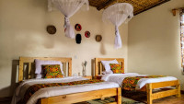

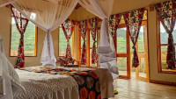

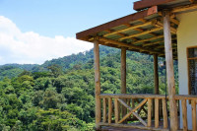

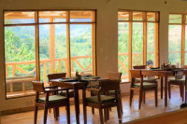

Day 1: Lunch & Dinner Included
Day 2: All Meals Included
- 3-4
Elephant Hab LodgeMid-range lodge just outside Kyambura Gorge (Chimps)

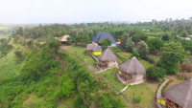

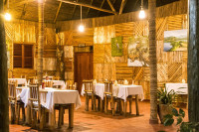

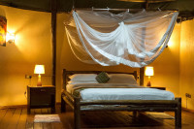

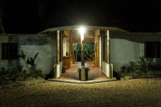+7Photos

All Meals Included
- 5
Isunga LodgeMid-range lodge just outside Kibale NP (Chimps)

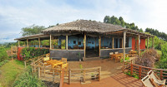

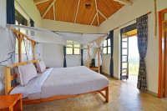

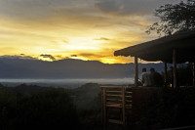

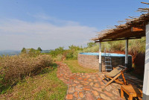+8Photos

All Meals Included
- 6
End of tour
(No accommodation)
Breakfast Included

Day by Day

Arrival (See Getting There for more details)
- You'll be collected from the airport.
- Accommodation before the tour starts can be arranged for an extra cost.
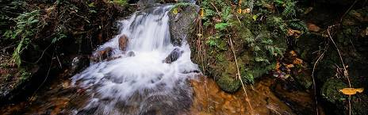

Day 1

Fly in to Kisoro Airstrip
Transfer to Entebbe airport and check in by 05:50 am. The Flight from Entebbe International Airport departs by 07:00 am and arrives in Kisoro by 08:10am. Meet and greet by our representative Guide/Driver, and after transfer to Your hotel/Lodge, You can opt for any optional activities available such as the Pygmy/Batwa Visit and nature walk among others.
Main Destination:
Bwindi Impenetrable National Park (Gorillas)
Best Time To VisitJune to August and December to February (Gorilla trekking is easiest)
High SeasonJune to September (Gorilla permits are scarce)
Best WeatherJune to July and December to February (Less rainfall)

Wildlife in Bwindi Impenetrable NP
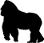
GorillaCommon

ChimpanzeeRare

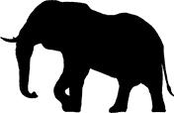
ElephantRare


White RhinoNone


Black RhinoNone


LionNone

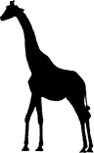
GiraffeNone


LeopardNone


CheetahNone


BuffaloNone

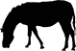
ZebraNone

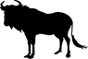
WildebeestNone


HippoNone
Accommodation:
Bweza Gorilla Lodge
- Mid-range lodge located just outside Bwindi Impenetrable NP (Gorillas)









Meals & Drinks:
- Lunch & dinner (Breakfast not included)
- Drinking water (Other drinks not included)
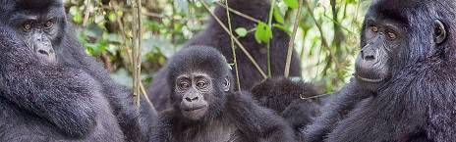

Day 2

Gorilla Trekking Experience
The highlight of your safari will be meeting the gentle giants of Bwindi impenetrable National Park. Enjoy the fullness of the impenetrable forest abounding with life, host to several species of birds, butterflies, primates, mammals. Eventually with help of your guide who is also a park ranger, you will find yourself face to face with the enormous and rare mountain gorillas.
The trekking experience takes anything from on hour (rarely) to about 8 hours to accomplish. However, you only have one hour with gorillas to capture your finest moment. You can also opt for the Gorilla Habituation experience that gives 4 hours experience with the Gorillas.
Main Destination:
Bwindi Impenetrable National Park (Gorillas)
Accommodation:
Bweza Gorilla Lodge
- Mid-range lodge located just outside Bwindi Impenetrable NP (Gorillas)
Meals & Drinks:
- All meals included
- Drinking water (Other drinks not included)
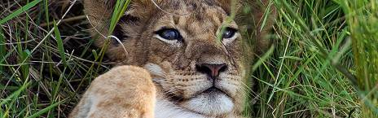

Day 3

Fly to Queen Elizabeth National Park
After a mouth-watering breakfast, you will transfer to Kisoro Airport for a flight to Kasese Airport, upon arrival, you will check at your lodge, have lunch and after go for an evening game drive in the Kasenyi plains of Queen Elizabeth National park, you will have a chance to view different animals in their natural habitat including lions, leopards, elephants, hippos, different species of antelope and many birds among others, you will have opportunity to enjoy the evening sunset from the African Savannah.
Main Destination:
Queen Elizabeth National Park
Best Time To VisitJanuary to February and June to July (Dry seasons)
High SeasonJune to September (Peak time for Uganda)
Best WeatherJune to July and January to February (Less rainfall)

Wildlife in Queen Elizabeth NP
ChimpanzeeOccasional


ElephantCommon


LionCommon


BuffaloCommon


HippoAbundant


LeopardOccasional


GiraffeNone


White RhinoNone


Black RhinoNone


CheetahNone


ZebraNone


WildebeestNone

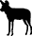
Wild DogNone
Accommodation:
Elephant Hab Lodge
- Mid-range lodge located just outside Kyambura Gorge (Chimps)







+7Photos

Meals & Drinks:
- All meals included
- Drinking water (Other drinks not included)
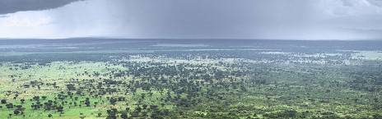

Day 4

Game drive and Boat Safari experience
After a cup of tea / coffee, to go for a game drive and catch up with the early risers, and predators trying to get back to their hideouts. Return for full breakfast and lunch at the Lodge, relax as we wait for lunch, later go for afternoon launch cruise on the Kazinga channel, famous for the highest concentration of Hippos in Africa, alongside other animals like Buffaloes, and huge crocodiles basking on the shores, as well as about 611 birds species.
Main Destination:
Queen Elizabeth National Park
Accommodation:
Elephant Hab Lodge
- Mid-range lodge located just outside Kyambura Gorge (Chimps)
Meals & Drinks:
- All meals included
- Drinking water (Other drinks not included)
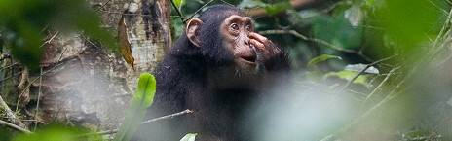

Day 5

Chimpanzee Trekking Experience
You will transfer by Road to Kibale National Park through very beautiful cater lakes, have lunch enroute or at the lodge before heading out for the afternoon Chimp Trekking Experience.
Kibale national park is the primate capital of East Africa. Chimpanzee trekking is a fulfilling adventure that takes you deep in the tropical forest across streams of water. You may also have sightings of red-tailed monkeys, black and white Colobus monkeys, butterflies, and birds calling from the canopies. With the help of your guide, you will locate the chimps. Enjoy picture moments and watch them as they play and feed. Optional Community visit is available after your trek.
Main Destination:
Kibale National Park (Chimps)
Best Time To VisitJanuary to February and June to July (Chimp trekking is easiest)
High SeasonJune to September (Peak time for Uganda)
Best WeatherJanuary to February and June to July (Least rain)

Wildlife in Kibale NP
ChimpanzeeCommon


ElephantOccasional


BuffaloOccasional


LionVery Rare


LeopardVery Rare


HippoRare


GiraffeNone


White RhinoNone


Black RhinoNone


CheetahNone


ZebraNone


WildebeestNone
Accommodation:
Isunga Lodge
- Mid-range lodge located just outside Kibale NP (Chimps)







+8Photos

Meals & Drinks:
- All meals included
- Drinking water (Other drinks not included)
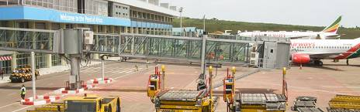

Day 6

Fly to Entebbe International Airport
You will transfer to Kasese Airport for your domestic Flight to Entebbe International Airport, you can opt for an early morning domestic Flight or mid-Morning/Day Flight. Optional Road Transfer is available upon request.
Main Destination:
Entebbe (City)
Accommodation:
No accommodation (End of tour)
Meals & Drinks:
- Breakfast (Lunch & dinner not included)
- Drinking water (Other drinks not included)

End of tour
- Additional accommodation can be arranged for an extra cost.
- You'll be dropped off at the airport.

Rates

Important to Know
- Rates are per person and exclude the international flight from/to your home country.
- This tour accepts children who are 15 years and older.
- Rates include a fixed budget for flights during this tour. Flights may cost more, depending on travel dates. If so, your quote will reflect this.

Rates Per Person
Start dates | Solo1 room | 2 people1 room | 3 people2 rooms | 4 people2 rooms | 5 people3 rooms | 6 people3 rooms
Jan 1, 2025 - Dec 31, 2025 | $4,653 | $3,625 | $3,388 | $3,245 | $3,190 | $3,119
Jan 1, 2026 - Dec 31, 2026 | $4,653 | $3,625 | $3,388 | $3,245 | $3,190 | $3,119
Jan 1, 2027 - Dec 31, 2027 | $4,653 | $3,625 | $3,388 | $3,245 | $3,190 | $3,119

Inclusions

Included
- Park fees(For non-residents)
- Gorilla permits(One per person, non-resident)
- Chimp permits(One per person, non-resident)
- All activities(Unless labeled as optional)
- All accommodation(Unless listed as upgrade)
- A professional driver/guide
- All transportation(Unless labeled as optional)
- All flights during the tour
- All Taxes/VAT
- Roundtrip airport transfer
- Meals(As specified in the day-by-day section)
- Drinking water(On all days)

Excluded
- International flights(From/to home)
- Additional accommodation before and at the end of the tour
- Tips(Tipping guideline US$15.00 pp per day)
- Personal items(Souvenirs, travel insurance, visa fees, etc.)
- Government imposed increase of taxes and/or park fees
- Some meals(As specified in the day-by-day section)

